**Project Design Phase-II**

**Technology Stack (Architecture & Stack)**

|  |  |
| --- | --- |
| Date | 18 October 2022 |
| Team ID | PNT2022TMID23778 |
| Project Name | Project – Signs with smart connectivity for better road safety. |
| Maximum Marks | 4 Marks |

**Technical Architecture:**

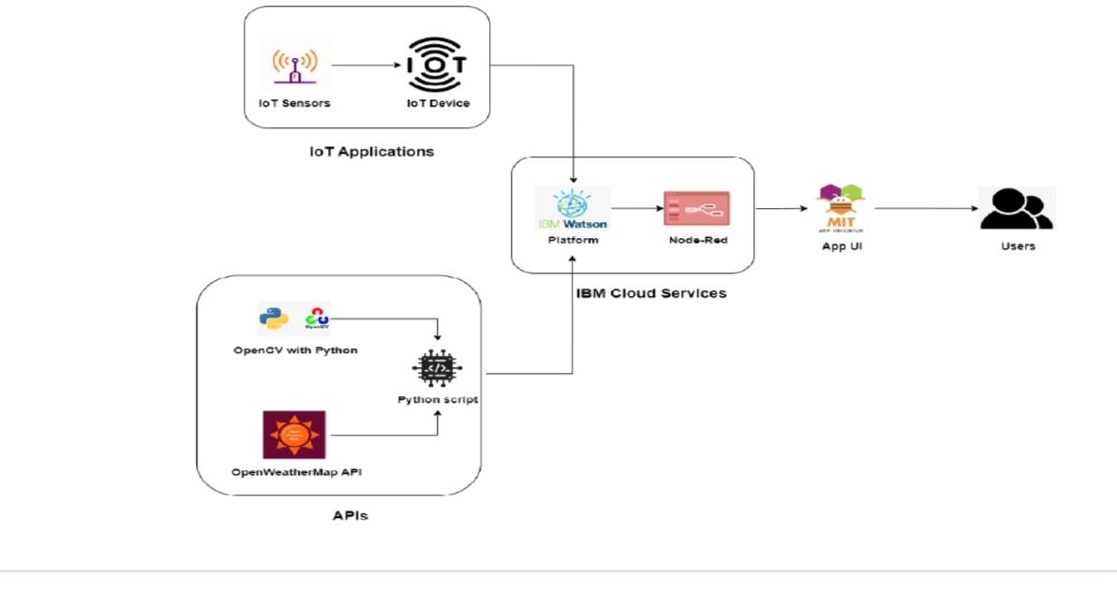

**Table-1 : Components & Technologies:**

|  |  |  |  |
| --- | --- | --- | --- |
| **S.No** | **Component** | **Description** | **Technology** |
|  | User Interface | User can interact with the app using MIT App | HTML, CSS, JavaScript / Angular Js / React Js |
|  | Application Logic-1 | Logic for a process in the application | Java / Python |
|  | Application Logic-2 | Logic for a process in the application | IBM Watson STT service |
|  | Application Logic-3 | Logic for a process in the application | IBM Watson Assistant |
|  | Database | Data Type, Configurations etc. | IBM Cloud |
|  | Cloud Database | Database Service on Cloud | IBM DB2, IBM Cloudant etc. |
|  | File Storage | File storage requirements | IBM Block Storage or Other Storage Service or Local Filesystem |
|  | External API-1 | Purpose of External API used in the application | Open Weather Map IBM. |
|  | External API-2 | Purpose of External API used in the application | IBM Watson Platform, Note - Red . |
|  | Machine Learning Model | Purpose of Machine Learning Model | OpenCV |
|  | Infrastructure (Server / Cloud) | Application Deployment on Local System / Cloud  Local Server Configuration:  Cloud Server Configuration : | Local, Cloud Foundry, Kubernetes. |

**Table-2: Application Characteristics:**

| **S.No** | **Characteristics** | **Description** | **Technology** |
| --- | --- | --- | --- |
|  | Open-Source Frameworks | Open Weather Map, NODE-RED, IBM WATSON,  MIT App Inventer. | IOT , Internet |
|  | Security Implementations | Powerful security system for everyone's Hackers cannot access network | Firewall, Firebase, cyber resillency, strategy. |
|  | Scalable Architecture | EASY TO EXTEND THE NETWORK WITH THE AID OF THE BANDWIDTH OF THE NETWORK | IBM cloud |
|  | Availability | Available every time and everywhere 24/7 so long as the consumer is signed into the network | IBM cloud |
|  | Performance | AIDS MASSIVE RANGE OF USERS TO USE TECHNOLOGY | IBM cloud |